Operating Systems Labs

# Lab 6- Installing Linux Ubuntu on VirtualBox[1]

## Part 1 – Installing Linux

There are several ways to install Linux. You can [clean everything from your system and install Linux](https://itsfoss.com/install-antergos-linux/). You can [dual boot Linux with Windows](https://itsfoss.com/guide-install-linux-mint-16-dual-boot-windows/) and choose one of the operating systems at the boot time. You can even [install Linux within Windows from Microsoft Store](https://itsfoss.com/install-bash-on-windows/) (though this only provides you with the command line version of Linux).

But if you want to use Linux without making any changes to your Windows system, you can go the virtual machine route. Basically, you install and use Linux like any regular Windows application. When you just want to try Linux for limited use, virtual machines provide the most comfortable option.

In this tutorial, I’ll show you how to install Linux inside Windows using VirtualBox.

## Installing Linux inside Windows using VirtualBox

[VirtualBox](https://www.virtualbox.org/) is free and open source virtualization software from Oracle. It enables you to install other operating systems in virtual machines. It is recommended that your system should have at least 4GB of RAM to get decent performance from the virtual operating system.

### Requirements

* Good internet connection to download software and Linux ISO. (You can also use some other computer with an internet connection to download these files.)
* Windows system with at least 12 GB of free space.
* Windows system with 4GB of rRAM. (It can work with less RAM as well, but your system will start to lag while using Linux in the virtual machine.)

I am installing Ubuntu 17.10 in this tutorial, but the same steps apply to any other Linux distribution.

### Step 1: Download and install VirtualBox

Go to the website of Oracle VirtualBox and get the latest stable version from here:

[Download VirtualBox](https://www.virtualbox.org/)

Installing VirtualBox is not rocket science. Just double-click on the downloaded .exe file and follow the instructions on the screen. It is like installing any regular software on Windows.

### Step 2: Download the Linux ISO

Next, you need to download the ISO file of the Linux distribution. You can get this image from the official website of the Linux distribution you are trying to use.

I am using Ubuntu in this example, and you can download ISO images for Ubuntu from the link below:

[Download Ubuntu Linux](https://www.ubuntu.com/desktop)

### Step 3: Install Linux using VirtualBox

You have installed VirtualBox and you have downloaded the ISO for Linux. You are now set to install Linux in VirtualBox.

Start VirtualBox, and click on the New symbol. Give the virtual OS a relevant name.

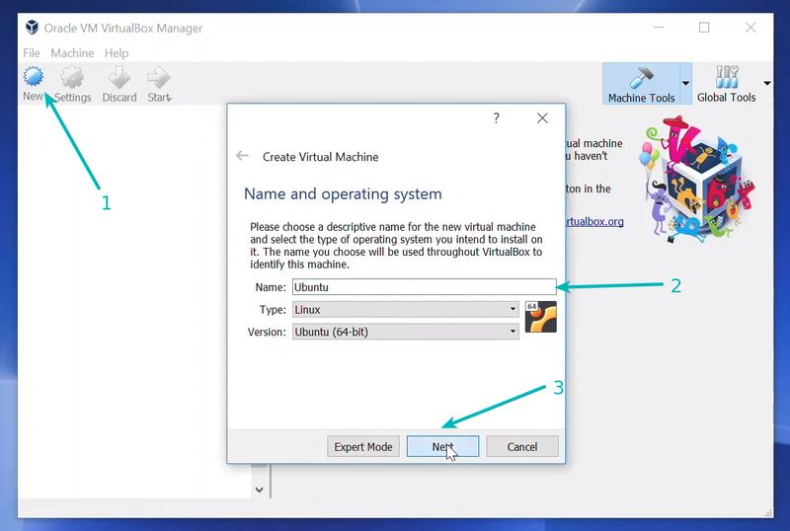

Allocate RAM to the virtual OS. My system has 8GB of RAM and I decided to allocate 2GB of it. You can use more RAM if your system has enough extra.

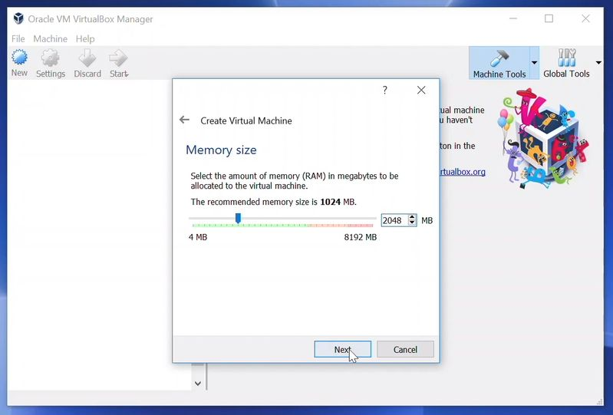

Create a virtual disk. This serves as the hard disk of the virtual Linux system. It is where the virtual system will store its files.

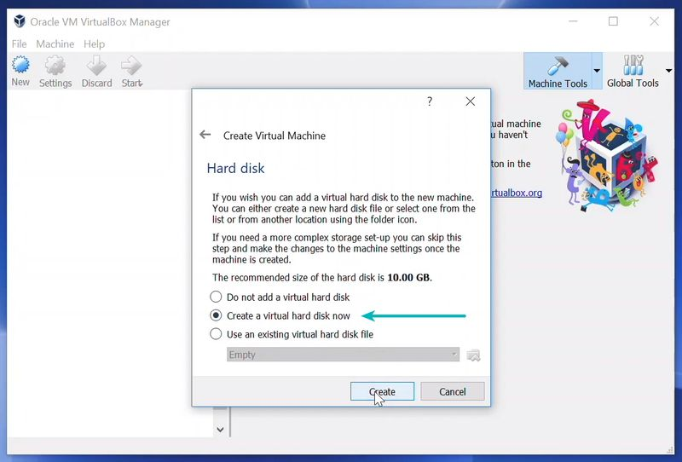

I recommend using the VDI file type here.

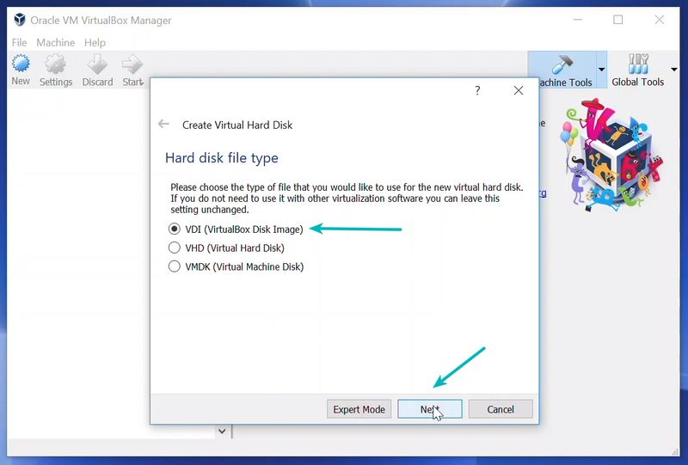

You can choose either the “Dynamically allocated” or the “Fixed size” option for creating the virtual hard disk.

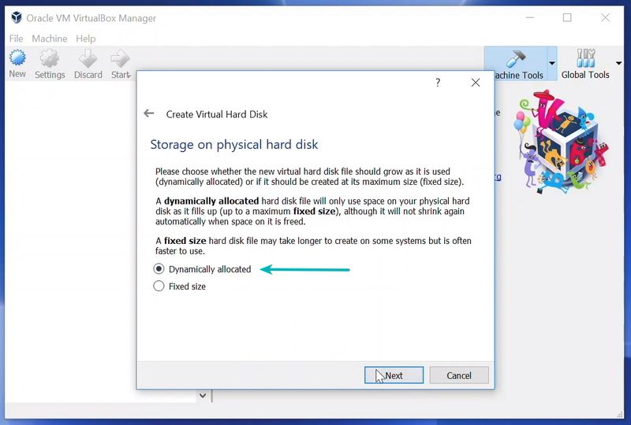

The recommended size is 10 GB. However, I suggest giving it more space if possible. 15-20 GB is preferable.

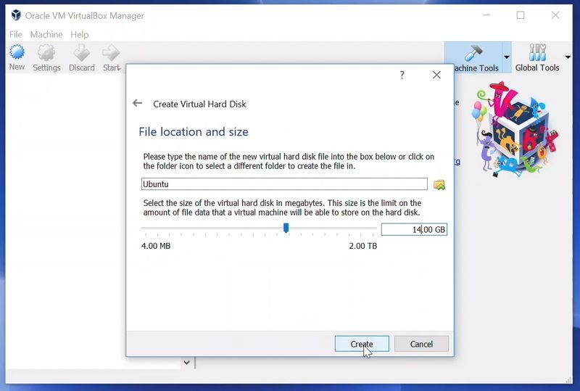

Once everything is in place, it’s time to boot that ISO and install Linux as a virtual operating system.

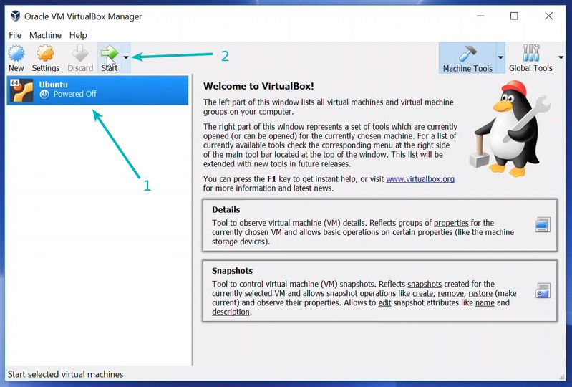

If VirtualBox doesn’t detect the Linux ISO, browse to its location by clicking the folder icon as shown in the picture below:

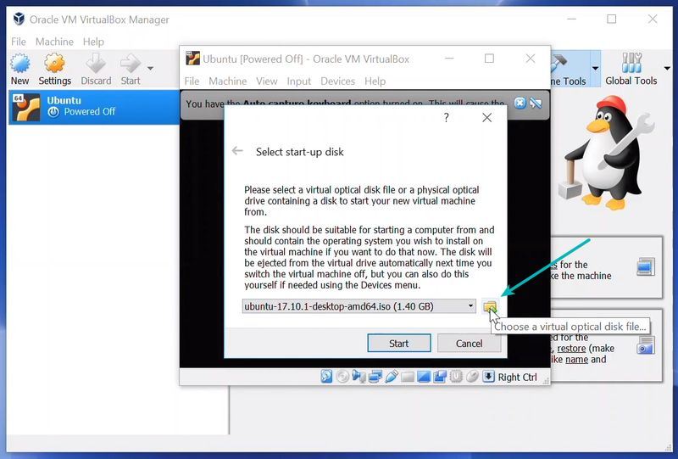

Soon you’ll find yourself inside Linux. You should be presented with the option to install it.

Things from here are Ubuntu-specific. Other Linux distributions may have slightly different looking steps, but it won’t be complicated at all.

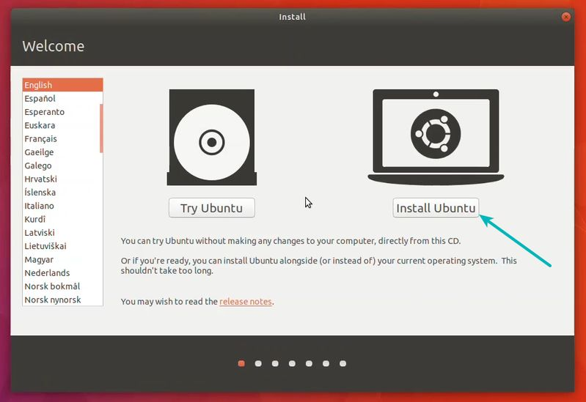

You can skip to Continue.

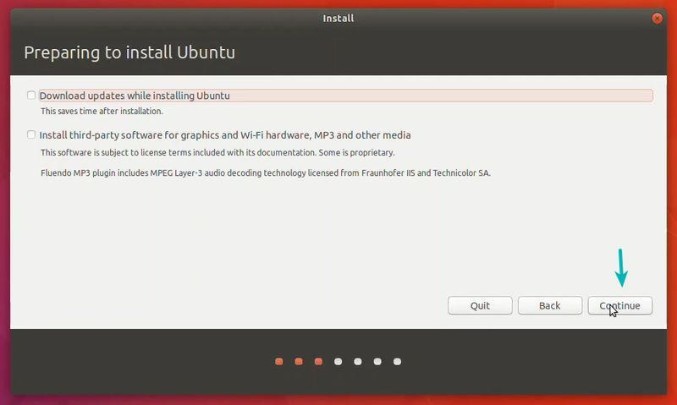

Select ‘Erase disk and install Ubuntu’. Don’t worry. It won’t delete anything on your Windows operating system. You are using the virtual disk space of 15-20GB that we created in previous steps. It won’t impact the real operating system.

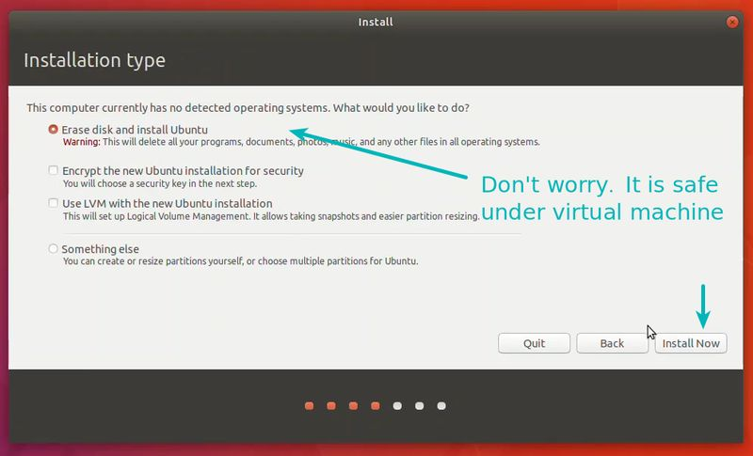

Just click on Continue.

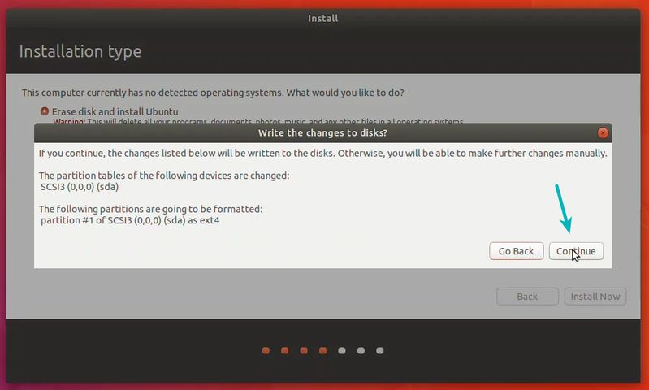

Things are pretty straightforward from here.

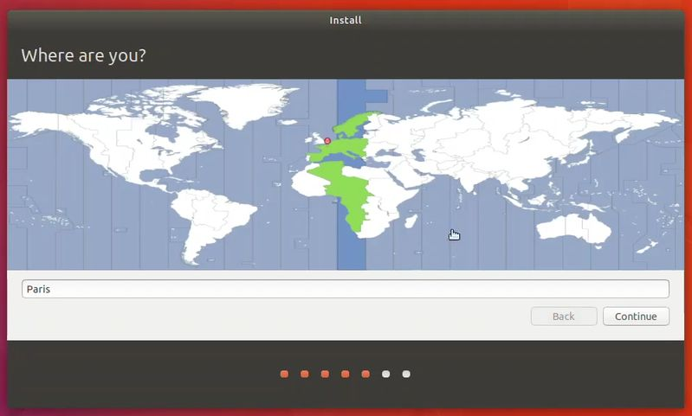

Self explanatory.

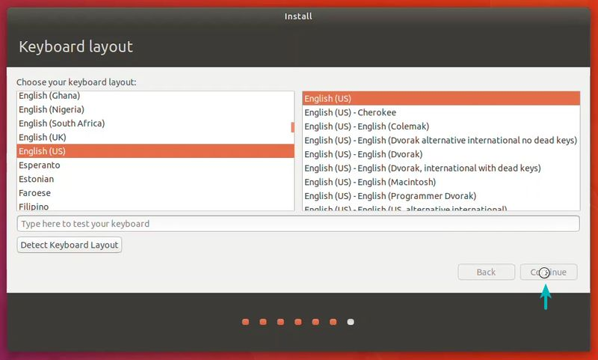

Try to choose a password that you can remember. You can also [reset the password in Ubuntu if you forget it](https://itsfoss.com/how-to-hack-ubuntu-password/).

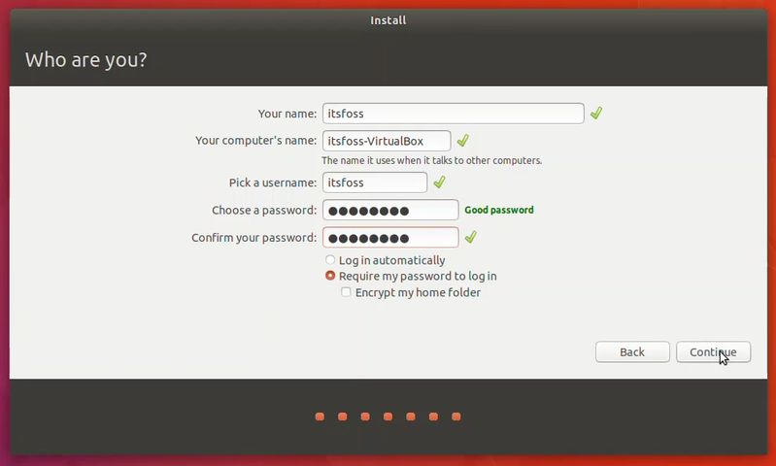

You are almost done. It may take 10-15 minutes to complete the installation.

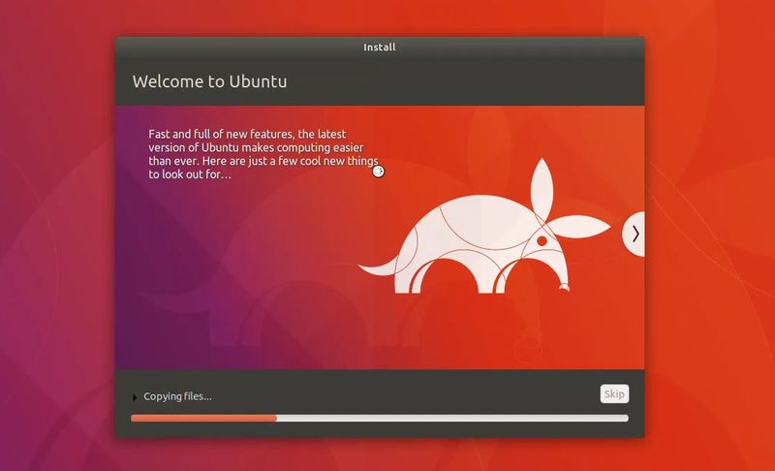

Once the installation finishes, restart the virtual system.

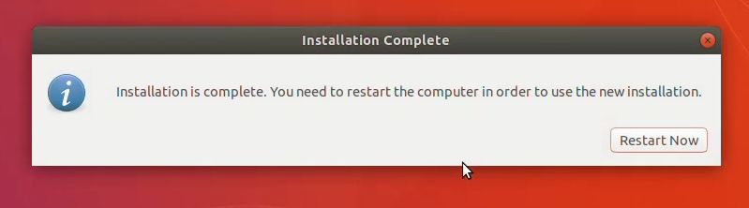

If it gets stuck on the screen below, you may close the VirtualBox.

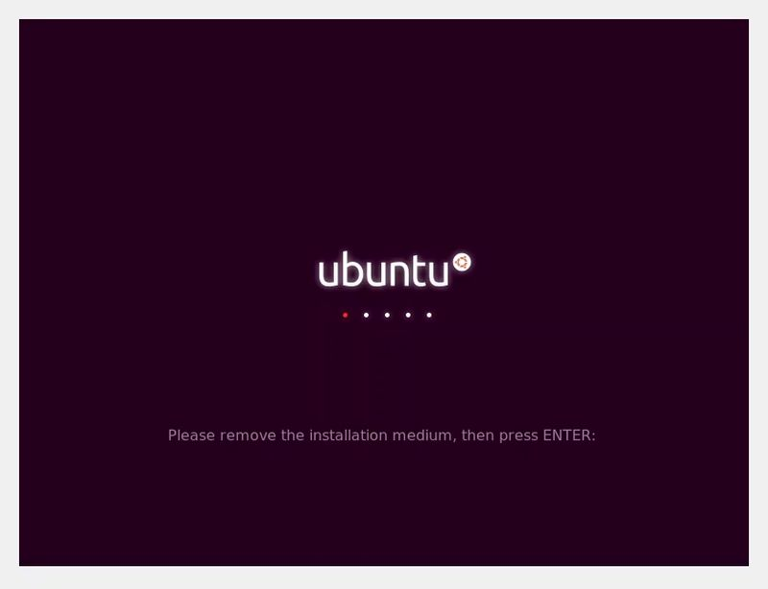

And that’s all. From now on, just click on the installed Linux virtual machine. You’ll be able to use it directly. The installation is a one time only process. You can even delete the Linux ISO that you downloaded earlier.

I strongly recommend [using VirtualBox Guest Additions on Ubuntu](https://itsfoss.com/virtualbox-guest-additions-ubuntu/) for it provides better compatibility and you would be able to use copy-paste and drag-drop between Linux and Windows.

### **Troubleshooting**: AMD-V is disabled in the BIOS

If you face this error while using the virtual machine:

Not in a hypervisor partition (HVP=0) (VERR_NEM_NOT_AVAILABLE).  
AMD-V is disabled in the BIOS (or by the host OS) (VERR_SVM_DISABLED).  
Result Code:  
E_FAIL (0x80004005)  
Component:  
ConsoleWrap  
Interface:  
IConsole {872da645-4a9b-1727-bee2-5585105b9eed}

This means that virtualization is blocked on your system. You’ll have to activate it in your BIOS settings first.

Reboot your system and as soon as it powers up, press F2/F10/F12 to access BIOS settings. You have to look for the virtualization option in the BIOS and enable it.

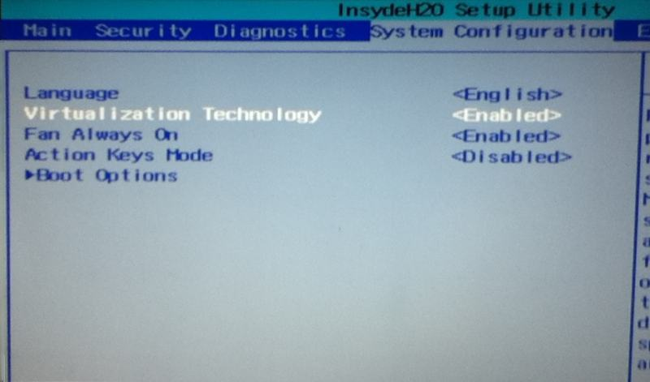*Enable Hardware Acceleration in BIOS |* [*Image Credit*](https://askubuntu.com/questions/118006/amd-v-is-not-enabled-in-virtualbox-on-amd-apu)

## Part 2- Linux Basics

## Installing Software[2]

Ubuntu has a Software Center using which you can install a host of applications. The Software Center is designed to search the Internet for available software which can be downloaded and installed.

**Step 1** − In the control panel, the Software Center appears on the left-hand side of the screen. In the following screenshot, it is encircled in a red box. Double-click to open it.

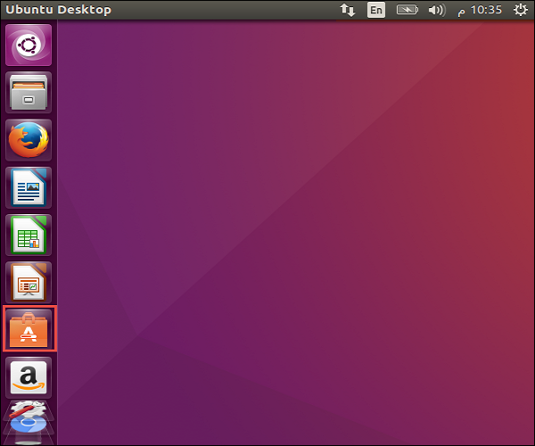

Once open, it shows the following options −

* View all the available software.
* All software currently installed on the machine.
* Any updates available for the software currently installed on the machine.

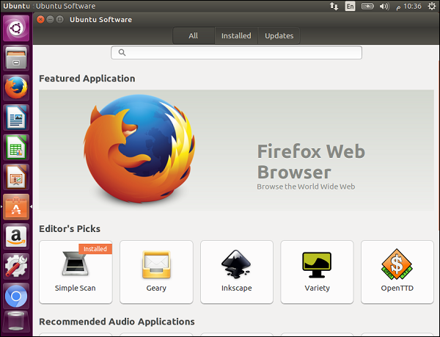

**Step 2** − We can also browse through various software categories. For example, let’s click the Audio category. We can see a list of available software for installation. As seen in the following screenshot, the application ‘Rhythmbox’ has already been installed.

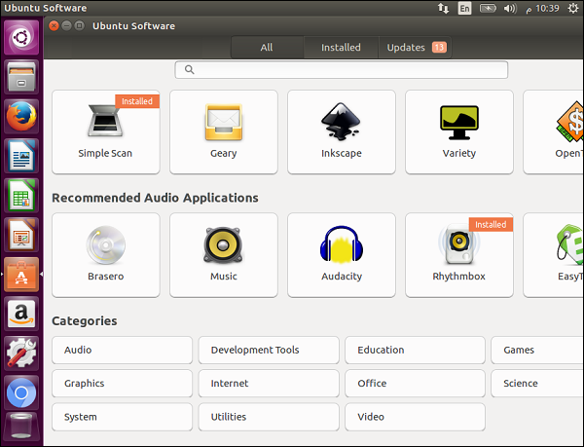

**Step 3** − Now let us choose an application, say the Music application and see how it installs.

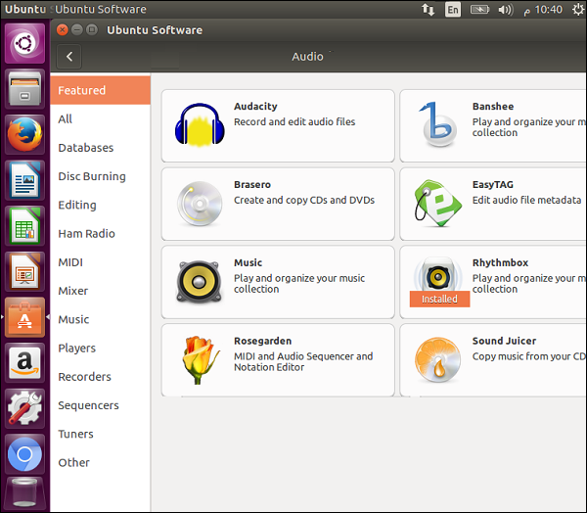

**Step 4** − Once we click the Music application, the following screenshot pops up. Click the Install button to begin the installation.

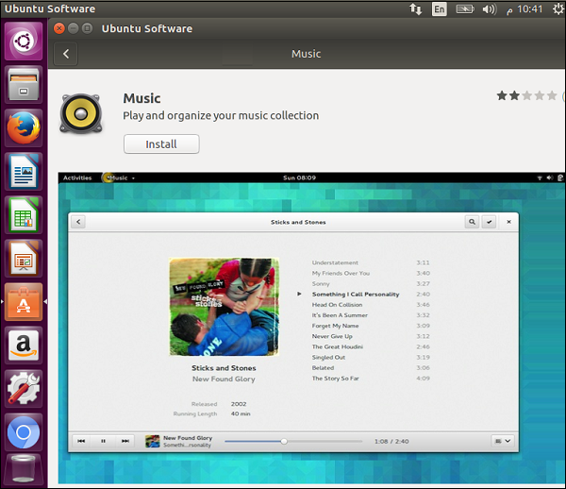

We will then see the Installing progress bar to show that the Music application is being installed.

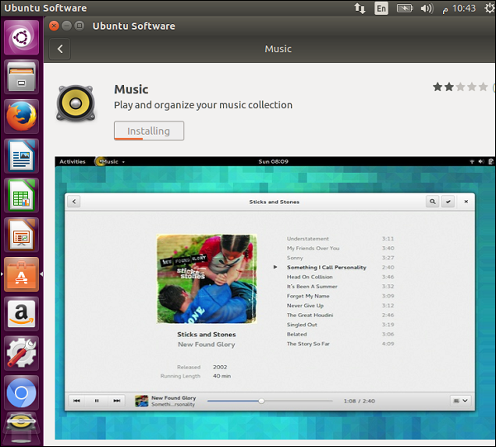

**Step 5** − Once the installation is complete, click the Launch button to launch the software.

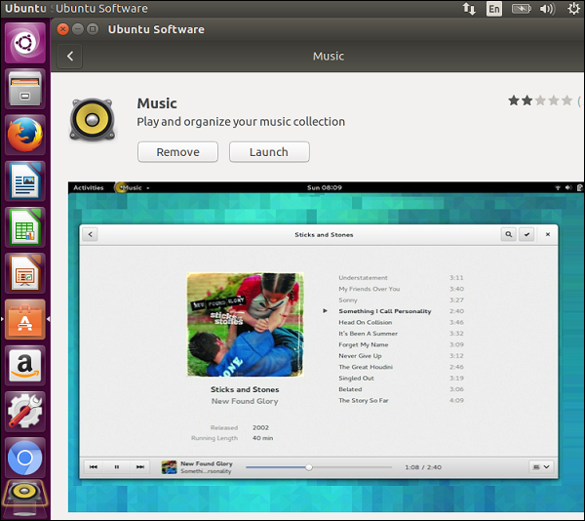

## Removing Software

To see the list of already installed software on the machine, go to the Installed section of the Software Center application. This presents an option to remove the unwanted software if required, as shown in the following screenshot.

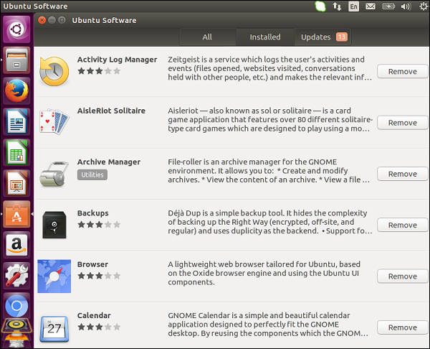

To remove any unwanted software, click the Remove button associated with the required software.

## Updates

In the updates section, we can install critical updates available for the Ubuntu operating system. This section also shows the updates available for the software already installed on the system.

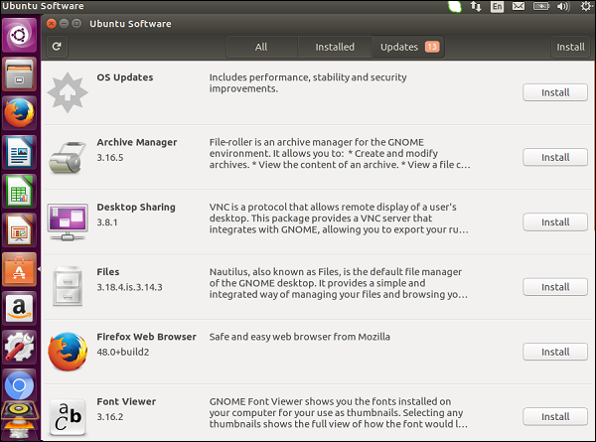

Click the Install button next to the desired update that needs to be installed.

# Ubuntu - Files and Folders[3]

To open the file like explorer in Ubuntu, click the Files option in the software launcher. In the following screenshot the Files icon is encircled in red.

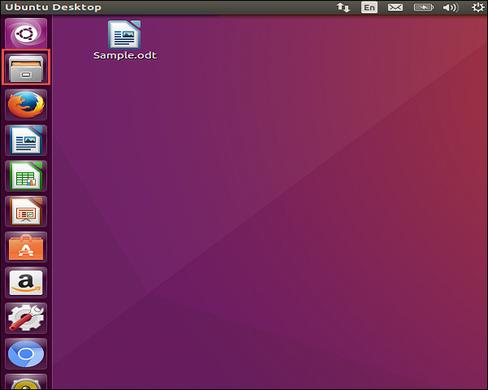

On clicking the icon, the following screen which is the File like explorer in Ubuntu opens up.

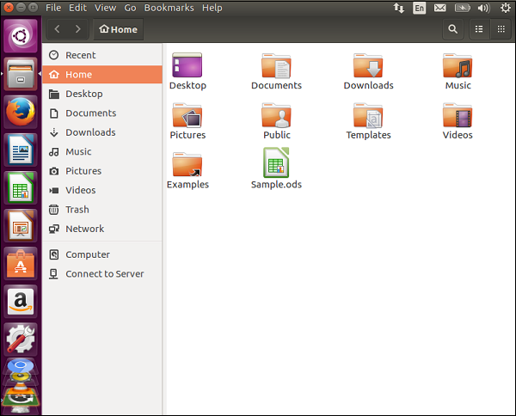

## Creating a Folder

**Step 1** − To create a folder, choose a location where the folder needs to be created.

**Step 2** − Then right-click and choose the option of New Folder.

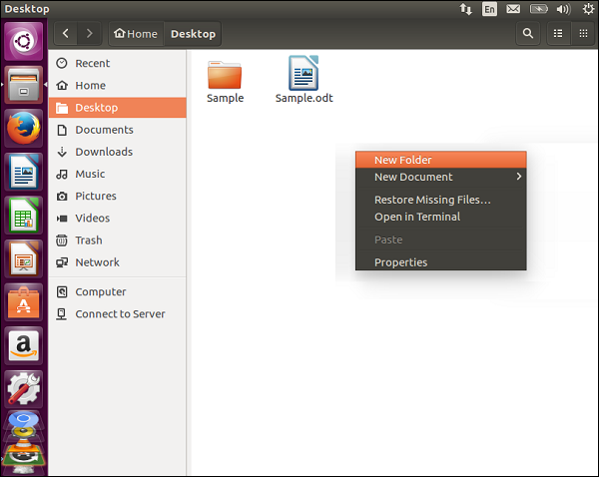

**Step 3** − Provide a name for the folder accordingly.

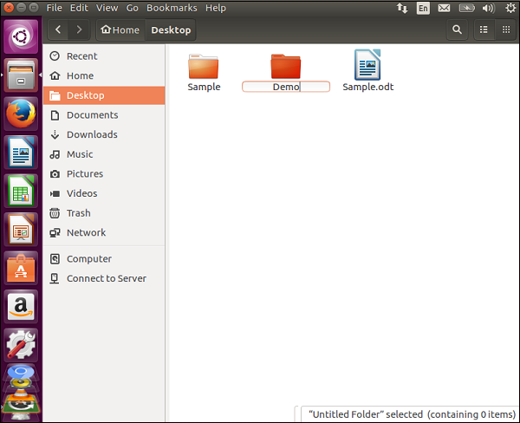

## Renaming a Folder

**Step 1** − To rename a folder, right-click the folder which needs to be renamed.

**Step 2** − Right-click and choose the rename option from the context menu.

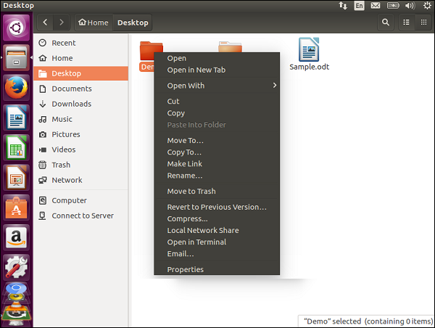

**Step 3** − Provide the new name of the folder accordingly.

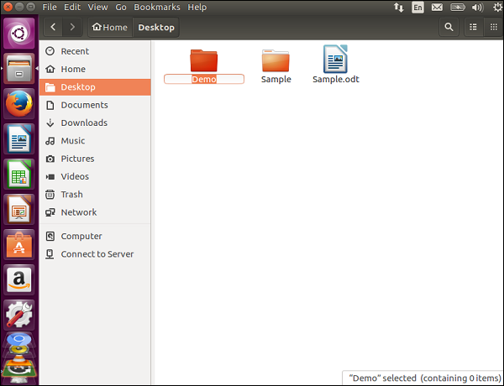

**Note** − There are other options such as move or copy the folder or move the folder to trash.

## Seeing the Properties of a File

To see the properties of a file, right-click the file and choose the Properties option from the context menu.

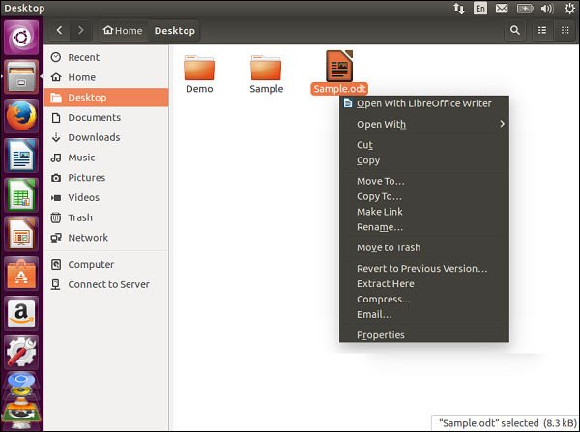

Using the option, we can view the properties of the file and modify the permissions of the file accordingly as shown in the following screenshot.

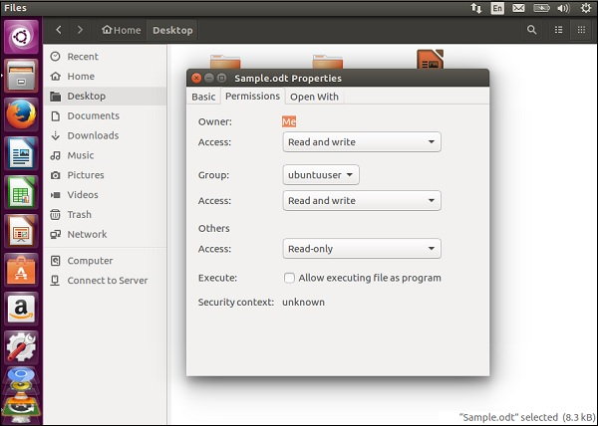

# Ubuntu - Word Writer[4]

The Word Writer comes in-built in Ubuntu and is available in the Software launcher.

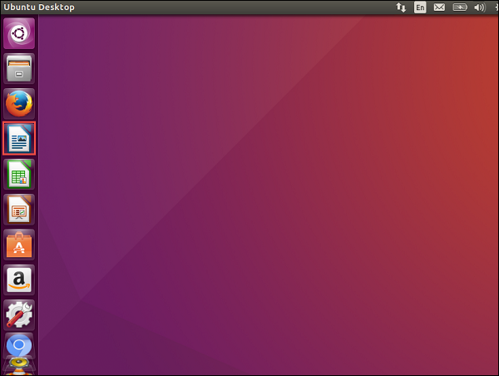

The icon is encircled in red in the above screenshot. Once we click on the icon, the writer will launch.

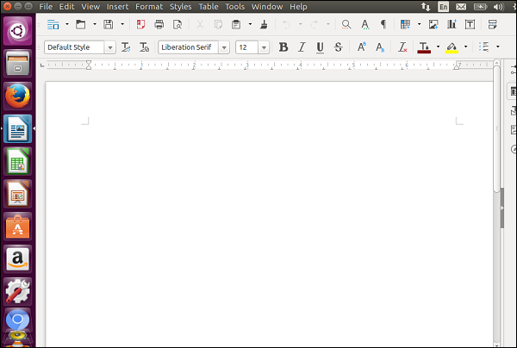

We can start typing in the Writer as we normally would do in Microsoft Word.

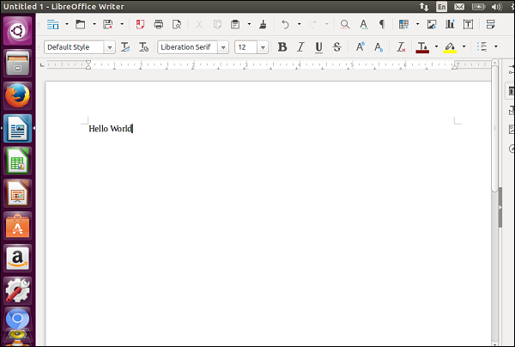

## Saving Documents

To save a document, just click on the save menu option as shown in the following screenshot.

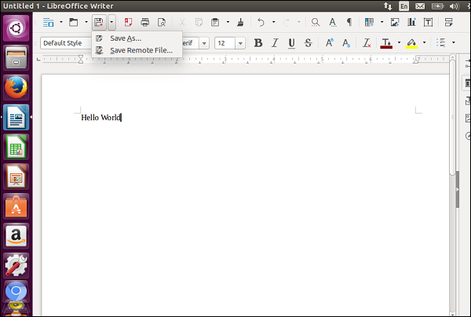

Specify the location, the name of the file and then click the Save button.

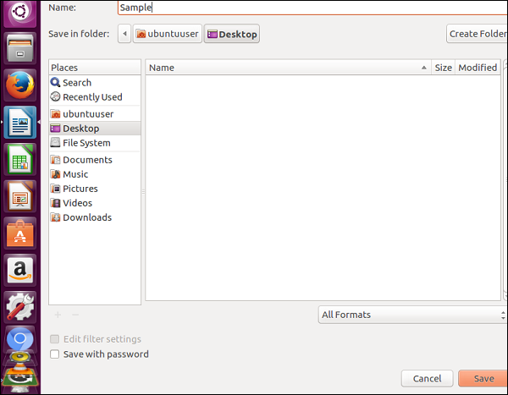

## Creating New Documents

To create a new document, choose the new menu option as shown in the following screenshot. It shows an option to create various types of documents.

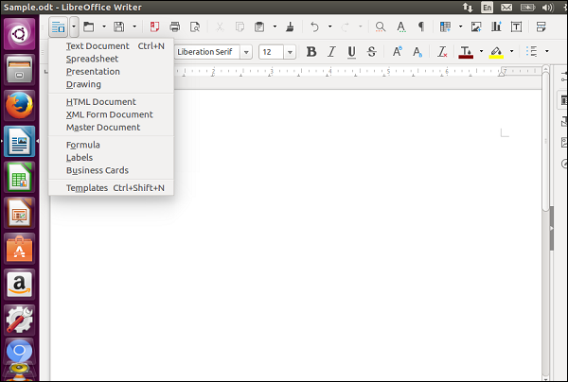

## Opening an Existing Document

To open an existing document, choose the option of opening an existing document from the file menu options as shown in the following screenshot. The option icon is encircled in red.

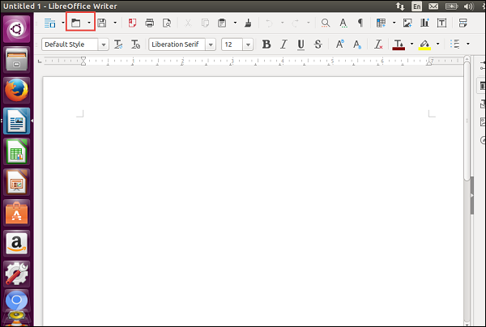

Once the open menu option is clicked, it presents a dialog box with an option to choose the file which needs to be opened. Click on the desired file and then click Open.

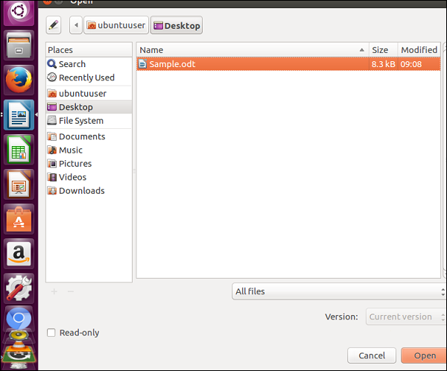

## Working with Tables

Tables can be inserted using the Insert table option as shown in the following screenshot.

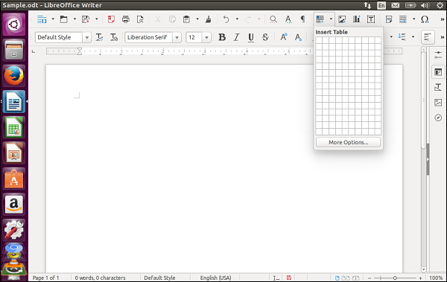

Once the table has been added, we can then work on the table as we would on Microsoft Word.

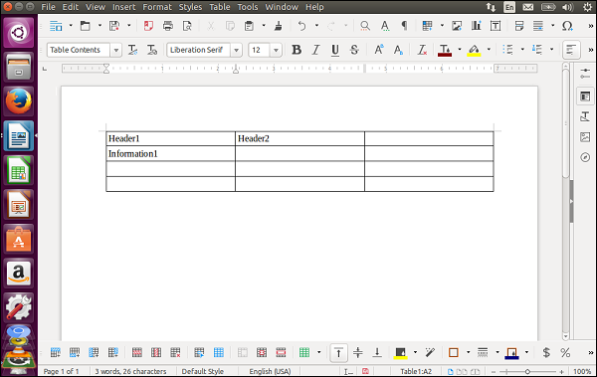

To add additional rows and columns work to the table, right-click on the table and choose the various table options available.

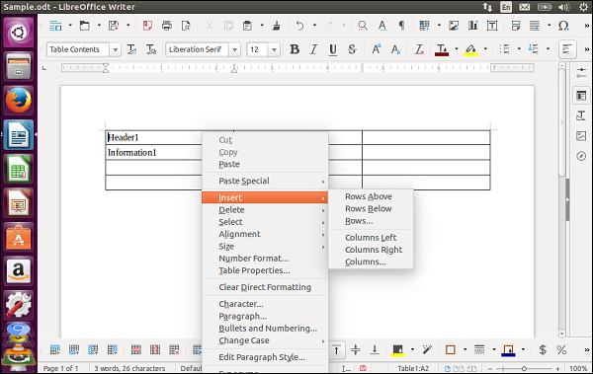

You can also work with the format of the text using the various font options in the toolbar of Word Writer.

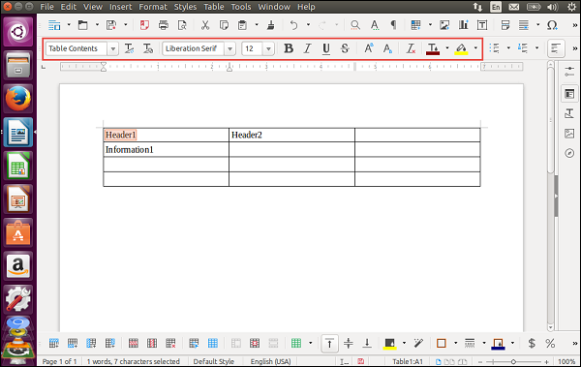

# Ubuntu - LibreOffice[5]

LibreOffice is a suite of office products available in Ubuntu. It is similar to the Microsoft suite of products although there are some features of Microsoft Office that does not work with LibreOffice and vice versa.

LibreOffice was first introduced in the year 1985 by a company called StarOffice. In the year 2002, the suite was taken by OpenOffice.org with Sun Microsystems being a major contributor to the product. From the year 2010 onwards, a separate branch of the source code of the product was taken which is now known as LibreOffice.

We will look at the LibreOffice writer and Calc in subsequent chapters. In this chapter, we will look at **LibreOffice Impress** which is the PowerPoint version of Microsoft.

The LibreOffice suite comes in-built in Ubuntu and is available in the Software launcher.

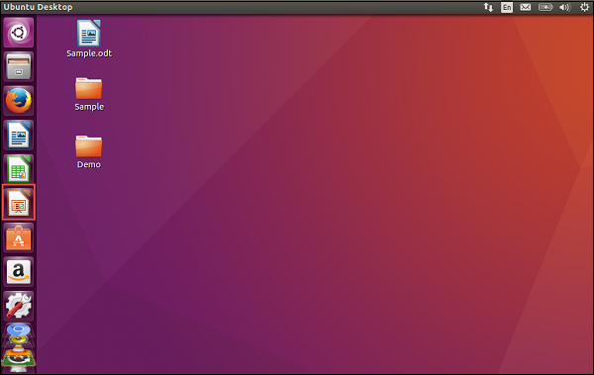

The icon of LibreOffice is encircled in red in the above screenshot. Once we click on the icon, the Impress Software will launch and the following screen will pop up.

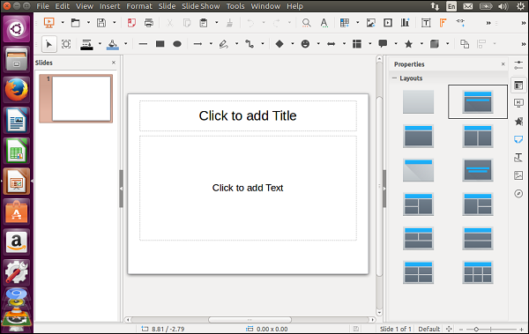

The interface looks quite similar to Microsoft PowerPoint. We can then modify the content on the slides as required.

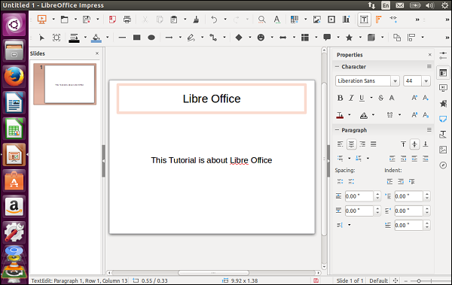

## Adding Slides

Adding slides to Impress is pretty similar to Microsoft PowerPoint. There are multiple ways of adding slides. One way is to use the Duplicate Slide option.

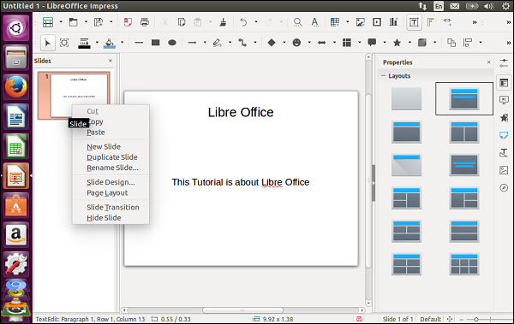

We can decide on the slide layout of the new slide by choosing the layout from the layout panel that appears on the right-hand side of the screen.

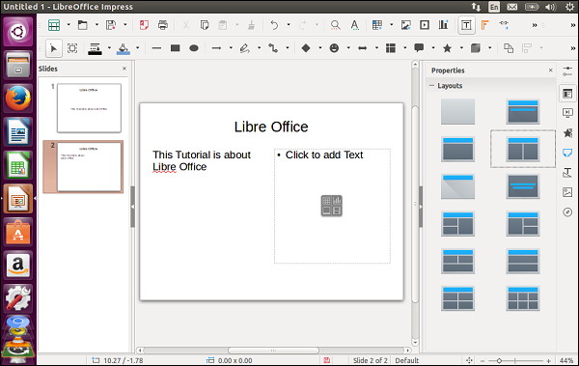

## Saving Slides

To save the presentation, choose the ‘Save As’ menu option.

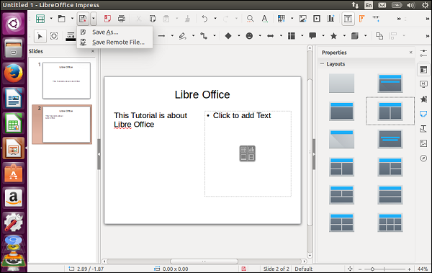

Provide the name and location of the slide and click the Save button.

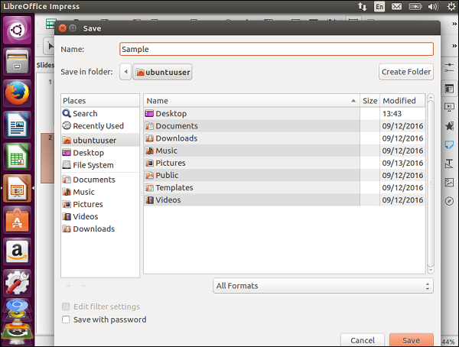

## Opening Slides

To open an existing presentation, click the Open menu option.

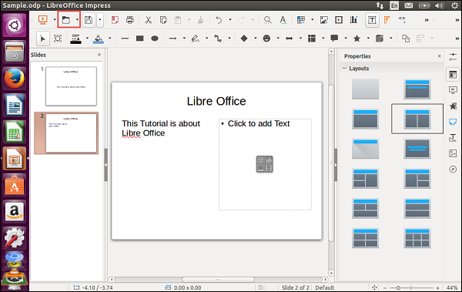

Choose the location and name of the file. Click the Open button to open the presentation.

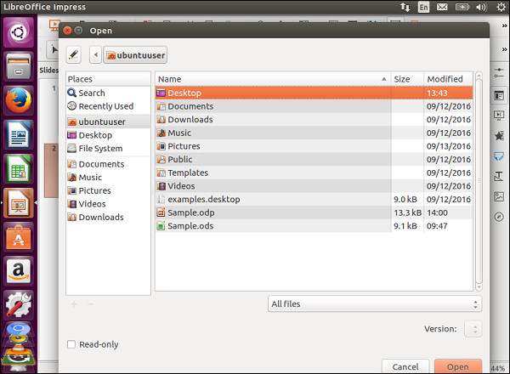

Useful Sites:

<https://itsfoss.com/getting-started-with-ubuntu/> ,   
<https://itsfoss.com/things-to-do-after-installing-ubuntu-18-04/> , and <https://www.lifewire.com/beginners-guide-to-ubuntu-2205722>

1. <https://itsfoss.com/install-linux-in-virtualbox/>
2. <https://www.tutorialspoint.com/ubuntu/ubuntu_software_center.htm>
3. <https://www.tutorialspoint.com/ubuntu/ubuntu_files_and_folders.htm>
4. <https://www.tutorialspoint.com/ubuntu/ubuntu_word_writer.htm>
5. <https://www.tutorialspoint.com/ubuntu/ubuntu_libreoffice.htm>